Zack Chambers

CST 221

John Zupan

February 10, 2019

GitHub Link: <https://github.com/zchambers3/CST-221/tree/master/Final>

**Assessing Virtualization Software**

I have chosen to research is Hyperconverged Infrastructure, also known as HCI. Hyperconvergence is an IT framework that is the combination of compute, storage, networking and virtualization resources into a single system. It is meant to streamline the deployment, management, and scaling of datacenter resources. It allows for an organization to provide great mobility in workloads, applications, scale in/out resources and restore data.

Hardware is broken up into pieces that are fitted to work together with different software ports in an operating system. For example, servers are configured with their own software interface, networking gear that has its own hardware and software specifically built to allow it integration compatibility, and storage systems need to be monitored by the kernel and memory management system. With HCI, all these components are constructed virtually and managed by the same set of tools and devices. This allows all aspects of each partition to allocate as needed, when more memory is needed the HCI allocates it. This type of design also scales very easily, when you need more than your current system has capacity for, you simply install a new set of nodes and improve the overall performance of the system. HCI allows companies to start small and expand their resources over time. Vendors also see a drastic potential in cost savings in areas such as IT labor, data center power and space, disaster recovery tools and possibly avoiding licensed software.

*Diagram of architecture of the virtualization environment*

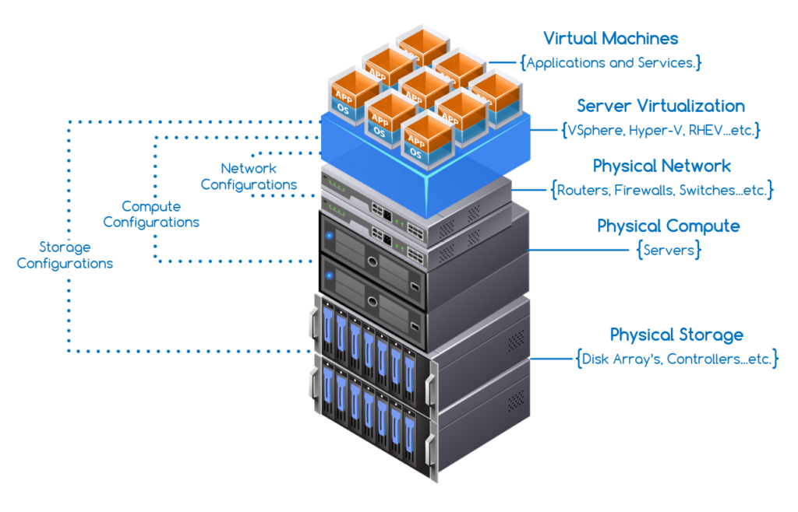

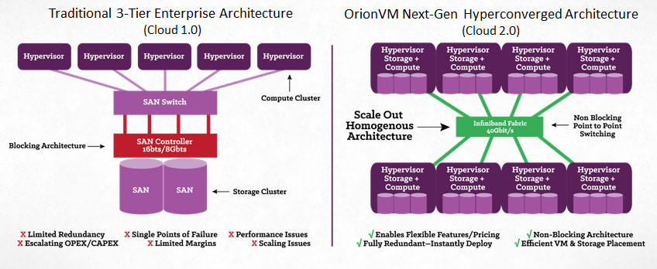

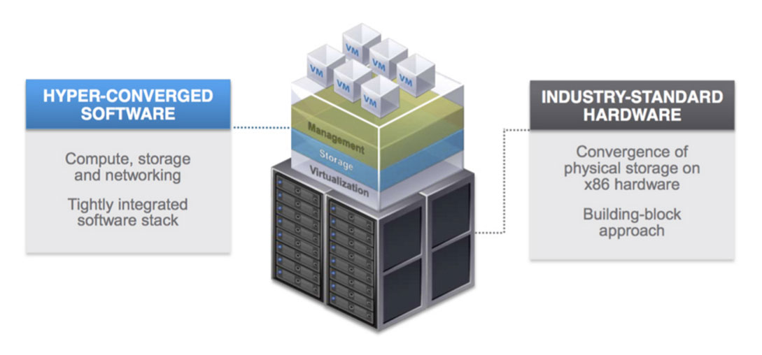

Virtualization Solution 1

|  |  |  |
| --- | --- | --- |
| **Category** | **Score** | **Reasoning** |
| Company Name |  | Nutanix |
| Product Name |  | Nutanix AHV |
| Version |  | AOS 5.6 |
| Release Date |  | April 2018 |
| Performance Metrics | 3 | While great in mechanics, it lacks advanced security, machine backup and migration. |
| Cost | 1 | $75,000.00 for a 3-node appliance is only feasible for massive corporations. |
| Disaster Recovery Capabilities | 4 | Clusters easily create and store snapshots of a failing VM which can be recovered from any other node. |
| Availability | 3 | VM’s are easily created and managed. Models are slightly limited. |
| Security | 3 | Standard security. |
| Infrastructure Scaling | 4 | New nodes are easily combined for scalability. |
| Management tools | 5 | Easily locate all VM’s and nodes with only two management panes. |
| Report Generation | 3 | Appears to have standard report generation tools. |
| Other: |  |  |

*Notes*

Virtualization Solution 2

|  |  |  |
| --- | --- | --- |
| **Category** | **Score** | **Reasoning** |
| Company Name |  | Dell EMC |
| Product Name |  | EMC VxRail |
| Version |  | 14th generation |
| Release Date |  | July 2017 |
| Performance Metrics | 4 | Very promising reviews with no negative comments. |
| Cost | 4 | Prices range from 2000 – 15000 per node, roughly equating to $45,000.00 for a standard 3 node model. Wider range of prices makes for a better score. |
| Disaster Recovery Capabilities | 5 | Can tolerate an entire site failure as well as local component failures with no data loss and zero down time. |
| Availability | 4 | Worldwide with many models. |
| Security | 4 | Cluster level encryption coupled with 2 factor authentications. Dell EMC RecoverPoint enables  rapid recovery if an attack occurs. |
| Infrastructure Scaling | 5 | Scales with more data types than the Nutanix. |
| Management tools | 5 | All virtualization management is done within the familiar Center Server interface. |
| Report Generation | 4 | Appears to have standard report generation. |
| Other: |  |  |

*Notes*

Virtualization Solution 3

|  |  |  |
| --- | --- | --- |
| **Category** | **Score** | **Reasoning** |
| Company Name |  | HPE |
| Product Name |  | Simplivity |
| Version |  | CN-2200 |
| Release Date |  | February 2017 |
| Performance Metrics | 4 | Mostly good reviews with few negative comments |
| Cost | 2 | 30,000 for single core and 70,000 for dual core with no support. |
| Disaster Recovery Capabilities | 5 | Built in rapid DR, 60 seconds to recover 1 TB data. Easily recover over 200,000 backups. |
| Availability | 4 | Globally Federated Architecture. |
| Security | 5 | Built in HPE Secure Encryption, data corruption easily detectable through fingerprint. |
| Infrastructure Scaling | 4 | Rapidly deploy and scale hyperconverged  building blocks to meet changing demands. It allows control of your infrastructure from one pane instead of having separate management portals for storage, servers, backup, etc. |
| Management tools | 5 | Single interface to view all data centers and remote branches. |
| Report Generation | 3 | Report generation not mentioned in any documentation or reviews. |
| Other: |  |  |

*Notes*

Virtualization Solution 4

|  |  |  |
| --- | --- | --- |
| **Category** | **Score** | **Reasoning** |
| Company Name |  | Cisco |
| Product Name |  | Springpath |
| Version |  |  |
| Release Date |  |  |
| Performance Metrics | 2 | Reviews did not look good, product seems to be lacking on many aspects. |
| Cost | 2 | Subscription starts at 12,000, requires 3 years minimum, that’s still 12,000 per year. |
| Disaster Recovery Capabilities | 4 | Enterprise-grade self-healing mechanism ensures  always-on operations during a server or disk failure. |
| Availability | 4 | ReadyClones, inline Deduplication and inline Compression allow for many different uses. |
| Security | 3 | Relatively new product exploits are not well known, and security is underdeveloped. |
| Infrastructure Scaling | 5 | Independent scaling of compute, caching and  capacity resources – add resources based on your  specific business needs. |
| Management tools | 5 | Seamless integration with VMware vCenter – get  started in minutes without learning curves. |
| Report Generation | 4 | Cloud monitoring continuously sends health and  usage updates about your infrastructure. |
| Other: |  |  |

*Notes*

Virtualization Solution 5

|  |  |  |
| --- | --- | --- |
| **Category** | **Score** | **Reasoning** |
| Company Name |  | NetApp |
| Product Name |  | NetApp HCI |
| Version |  |  |
| Release Date |  |  |
| Performance Metrics | 4 | Fair reviews but important detriments, lagging trendsetters, lack of quality of service. |
| Cost | 2 | 100,000 for 10 TB seems a bit more expensive than other brands. |
| Disaster Recovery Capabilities | 2 | Specifications hidden, unable to find reliable details. |
| Availability | 5 | First time there is specifications listed for individual nodes. |
| Security | 2 | Specifications hidden, unable to find reliable details. |
| Infrastructure Scaling | 4 | Fairly standard for this type of product. |
| Management tools | 4 | simple centralized management through a VMware Center Plug-in gives full control of your entire infrastructure through an intuitive user interface. |
| Report Generation | 2 | Specifications hidden, unable to find reliable details |
| Other: |  |  |

*Notes*

**Analysis of top choice**

My top choice would definitely have to be the Dell EMC VxRail. This product has the highest overall rating and tends to have better ratings in several other categories. Although it has not been around as long as NetApp the specifications that are listed prove to be greater than the longer running product. Furthermore, the VxRail can tolerate a site failure with no data loss and no downtime. The VxRail also can scale much better than any of the other models, especially the Springpath which is subscription based.

The fact that VxRail can accommodate a wider range of datatypes than some of the other brands also makes it the top pick, giving it a greater ability to virtualize all the nuances of an operating system. Documentation providing detailed change logs to the generational advancements is also provided for VxRail, making it more understandable and relatable. When it comes to companies not losing data, VxRail seems to be the best option available. This would be a large benefit to healthcare organizations who need to keep their patient’s personal information secure.

**Discussion of related topics**

*Topic 1*

One of the diagrams I came across portrayed this idea very accurately. Most of the time, the hardware-based approach can become very messy. When you want to increase the storage capacity of the overall unit you must install and connect each individual piece. Next, when you want to upgrade the processing power of the overall unit, you need to go ahead and do the same. The only way to improve hardware-based units is to consistently remove old pieces and then install new ones. This in turn creates more and more connections, each of which need to be managed, eventually leaving you with a giant mess of wires and connections. Comparatively, HCI allows for nodes to be used as needed. If you need more of any one resource, just connect more nodes to the device and you are set. There are no wires, no ports that needs to be configured, overall it is a much simpler process. Additionally, HCI is easier to manage, given that a new piece of hardware requires a new device manager, but additional HCI power is simply controlled with the already installed and user-friendly interfaces. A good example of this is the HPE Siplivity, which is capable of storing over 200,000 backups and then easily recovering to any one of them. Another example would be the Dell EMC VxRail, which can recover from a total site failure without any data loss. The structural layout of the Hyperconverged Infrastructure makes it superior to that of the hardware-based setup. All of this strictly depends on the size of the organization or tasks trying to be completed by the organization. Hardware-based HCI are easy to setup and deploy, offering a more of a plug and play type of system.

*Topic 2*

Binary translations are a means of low-level re-engineering focus on sending machine code from one system to another. Procedurally the source system translates the binary machine code into a higher-level abstract code before sending it to another machine which then interprets the rough calls and then places then through a binary machine code translator to generate new machine code. For example, this would be when a user on a network builds a program before sending it thorough the network to another user on a different device. If the other user might be working with a different version of the operating system, the translation is done to allow the new device to run the code. A situation where the translated code could be faster than the original code is if the target system has an updated version of the source system. In the case of HCI systems, the binary file would not even have to be put through translation as it would simply be accessed from the other VM. This is because each VM is using the same set of nodes that is available to the whole system, so there are no differences between the VM’s.

**References**

De Gelas, Johan. (2008). *Hardware Virtualization: The Nuts and Bolts*. Retrieved from <https://www.anandtech.com/show/2480/4>

Dell EMC. (2018). Dell EMC VxRail. Retrieved from <https://www.dellemc.com/en-us/converged-infrastructure/vxrail/index.htm>

Harshe, Charlene. (2017). Having a private cloud for my organization is valuable. Retrieved from <https://www.itcentralstation.com/product_reviews/hpe-simplivity-review-42296-by-charlene-harsch>

HPE.com. (2018). HPE Simplivity. Retrieved from <https://www.hpe.com/us/en/integrated-systems/simplivity.html>

ItCentralStation.com. (2018). *Cisco HyperFlex HX-Series vs Springpath*. Retrieved from <https://www.itcentralstation.com/products/comparisons/cisco-hyperflex-hx-series_vs_springpath>

ItCentralStation.com. (2018). *NetApp FAS Series vs Nutanix*. Retrieved from <https://www.itcentralstation.com/products/comparisons/netapp-fas-series_vs_nutanix>

NetApp. (2018). *NetApp HCI*. Retrieved from <https://www.netapp.com/us/products/converged-systems/hyper-converged-infrastructure.aspx>

Nutanix. (2018). *What is hyperconverged infrastructure*? Retrieved from <https://www.nutanix.com/hyperconverged-infrastructure/>

Rouse, Margaret. (2018). *Hyper-Convergence*. Retrieved from <http://searchconvergedinfrastructure.techtarget.com/definition/hyper-convergence>

Springpathinc.com. (2018). *Springpath*. Retrieved from <http://www.springpathinc.com/>

StoragePricing.org. (2018). *Nutanix Pricing*. Retrieved from <http://www.storagepricing.org/category/nutanix/>

StorageReview.com. (2017). *Dell EMC VxRail Overview*. Retrieved from <http://www.storagereview.com/dell_emc_vxrail_overview>

Ung, David. Cifuentes, Christina. (2005). Dynamic binary translation using run-time feedbacks. Elsevier B.V.

Wyman, Eric. (2016). *Nutanix Acropolis Review: "Making the jump to Acropolis is worth it*". Retrieved from <https://www.trustradius.com/reviews/nutanix-acropolis-2016-08-30-12-01-00>